

**Assignment 05**

**Training Program:** MERN Stack Development

**Trainer:** Ahsan Javed

**Topic:** JavaScript Basics

**Due Date:** August 18, 2024

**Task 1: Create a To-Do List Commad-Line Application**

* Allow the user to:
  + Add a new task to the To-Do list.
  + View all tasks in the To-Do list.
  + Mark a task as completed.
  + Delete a task.
* The tasks should be stored in an array.
* Each task should be an object with properties such as *id*, *description*, and *completed*.
* Display tasks with their status (completed or not completed).

**Add Task:** Prompt the user to enter a task description and add it to the list.

**View Tasks:** Display all tasks along with their IDs and status.

**Mark as Completed:** Prompt the user to enter the task ID and mark it as completed.

**Delete Task:** Prompt the user to enter the task ID and remove it from the list.

**Exit:** Provide an option to exit the application.

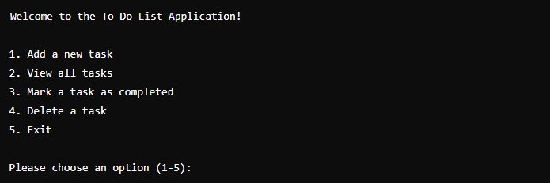

**Submission Guidelines**

* Create a JS file and write code in it. Save it as **fname-lname-a-05.js**, where fname is your first name and lname is your last name.
* Send the file at [ahsanjaved@skilovate.com](mailto:ahsanjaved@skilovate.com) with subject **Assignment 05**.